Removing Mercury Switches
Removing hood and trunk convenience lights:
In some instances (such as many GM vehicles), leaving the assembly intact and removing the pellet may be easier than removing the assembly.
1. Check for hood and/or trunk convenience light switches on the following cars and trucks. See list of vehicles containing mercury convenience light switches for more specific model information.
• GM, 2002 and older.
• Ford, 2001 and older.
• Chrysler, 1998 and older.
• Volvo, 1991 and older.
• 1977-1988 Audi 100 and 1980-1988 Audi 200
• Mazda, 1993-1997 Navajo and 1995-1999 B-Series pickup
• Porsche, 1976-1991
2. Disconnect the battery.
3. Find the small lighting fixture on the underside of the hood or trunk.
4. Cut the power supply wire to the fixture.
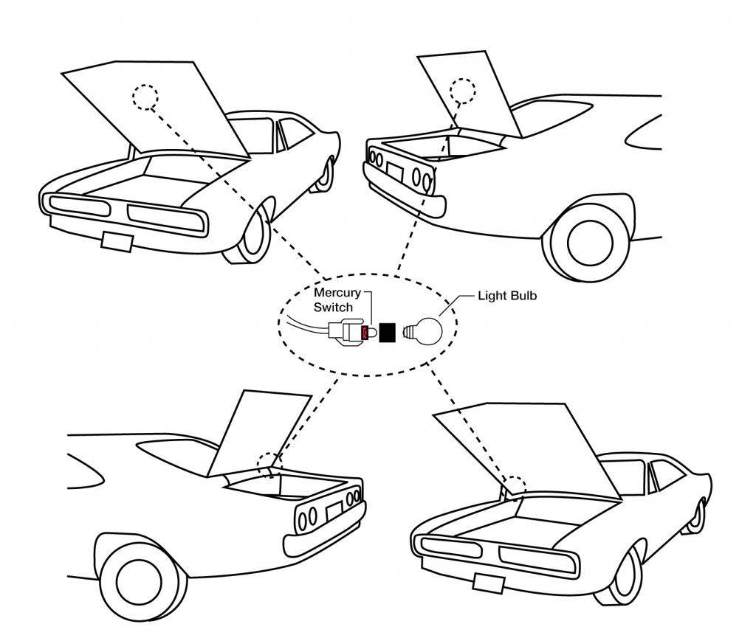
5. Remove any fasteners to separate light from vehicle.

Removing Vanity Mirror Sun Visor Switches
1. Check the following cars for a sun visor switch:
1986 - 1991 MY Volvos except for the 240.
2. Disconnect the battery.
3. Find the light assembly in the sun visor.
4. Remove the light assembly and cut the power supply.

Recycling Mercury Switches
Collecting and managing mercury-containing assemblies and pellets:
1. Determine if the vehicle should be checked for a switch assembly. If
unsure, check the list of likely vehicle years, makes and models provided.
2. If yes, see removal instructions above panel.
3. Remove the entire assembly. If the state requires pellet removal,
then remove the metal pellet from the assembly if possible. Please do not attempt to remove glass pellets from the assembly –leave intact.
4. Place the assembly and/or pellets in the plastic bucket. Properly labeled
containers with air-tight lids will be provided.
5. Replace the lid after each pellet or assembly is added.

